**CCD Experiment – 7**

**Aim**: To design and observe the circuit diagram of Tuned Amplifier Circuit in NI Multisim.

**Circuit Diagram:**

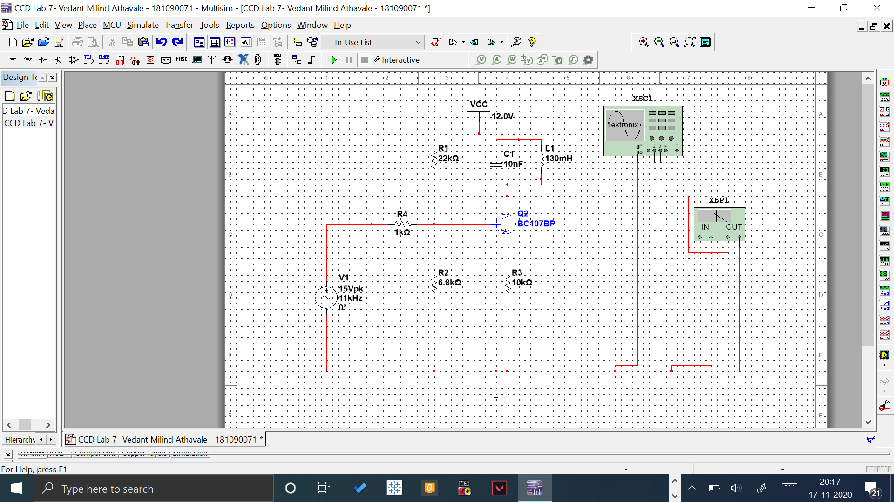

**Output:**

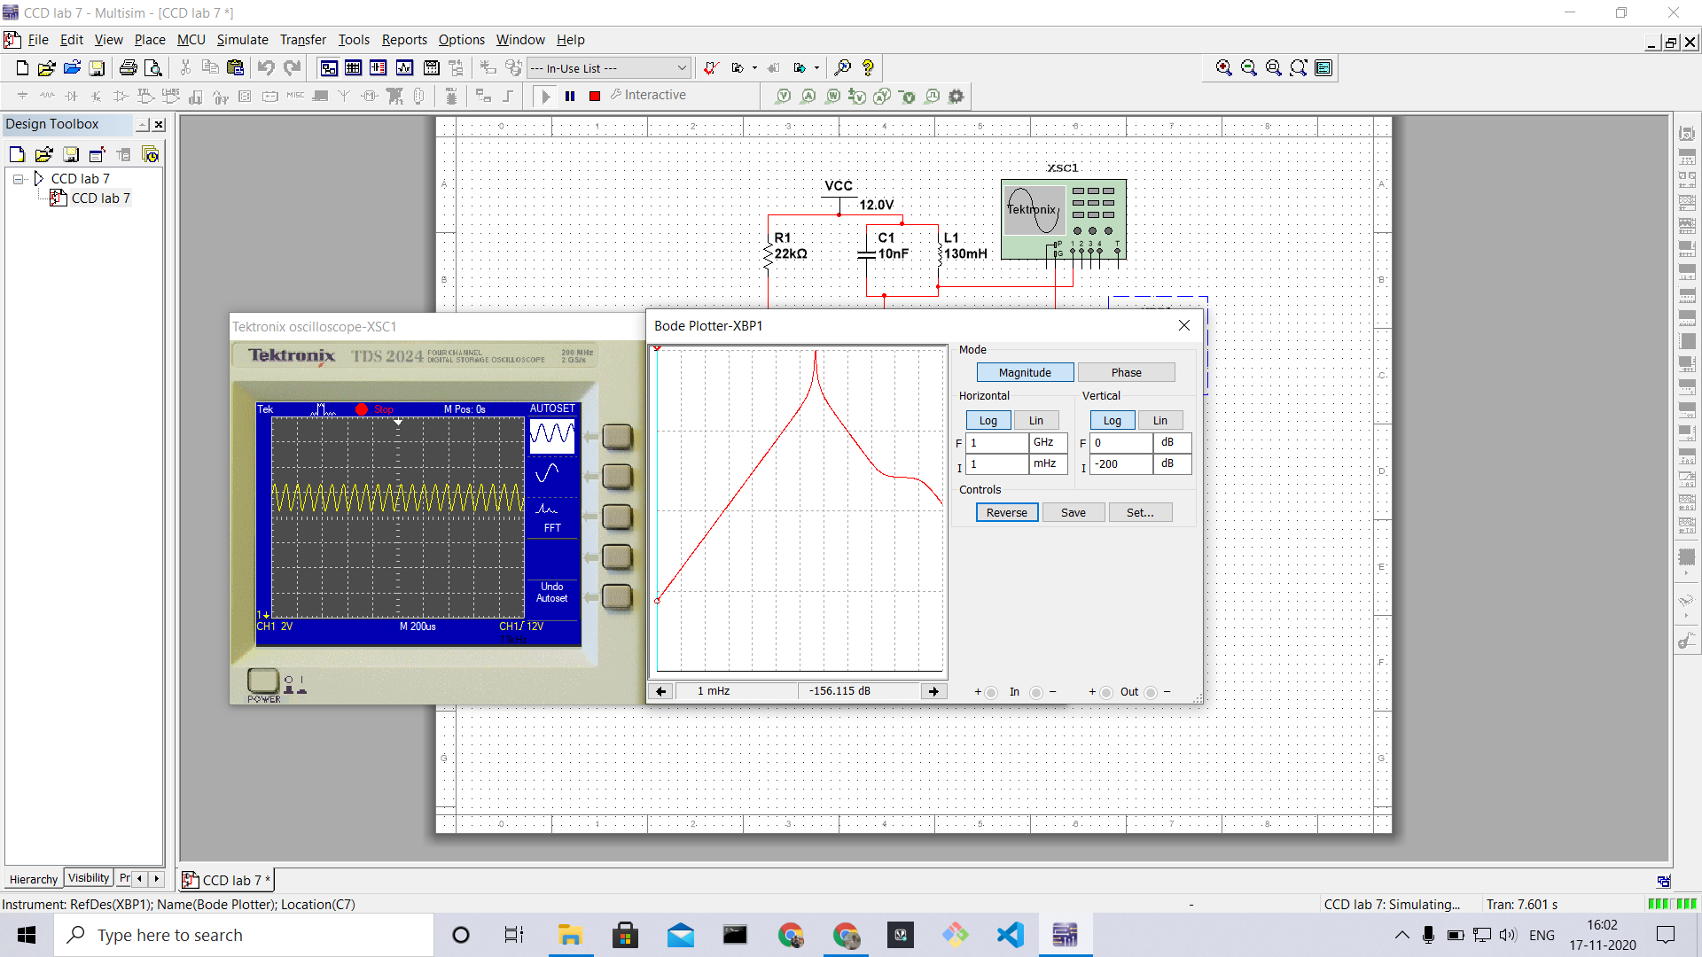

**Conclusion**: Designed and Observed the circuit diagram, working and output voltages and plots of tuned amplifier circuit.